**1. Project Overview**

This document outlines the planning and timeline for the AI-powered hotel reservation project, detailing key phases, activities, and deliverables. It ensures coordinated execution, efficient resource use, and adherence to timeline and quality standards.

**2. Sprint Breakdown**

**Sprint 1: Core Authentication & Home Page**

**Duration:** 1-2 weeks

**Objectives:**

* Lay the foundation for secure user access and a user-friendly interface.

**Key Tasks:**

* **Design Registration/Login UI:**Create detailed wireframes and mock-ups for registration and login screens.
* **Implement Authentication:**Code the core authentication functionalities using Laravel’s built-in features.
* **Email Verification Flow:**Set up an email verification process to validate newly registered user account.
* **Basic Search Bar + Filters:**Develop a simple search interface on the home page that accepts user inputs (keywords, destination, date, etc.) and supports basic filtering (price range, star rating).

**Expected Milestones:**

* Completion and internal testing of the authentication module**.**
* Functional email verification.
* Working basic search bar that responds to user inputs.

**Sprint 2: AI & API Integration**

**Duration:** 2 weeks

**Objectives:**

* Enhance the home page by integrating external data and intelligent recommendation capabilities.

**Key Tasks:**

* **Integrate Hotel Data APIs:**Establish stable connections with providers (e.g., docs.hotelapi) to fetch current hotel.
* **Build AI Recommendation Engine:**AI module that uses booking history to deliver personalized hotel recommendation.
* **Dynamic Sorting/Filtering:**Enhance search with dynamic sorting and filters using live API data and AI insights to.

**Expected Milestones:**

* A prototype of the AI recommendation engine that offers personalized hotel options.
* Enhanced search results reflecting dynamic sorting and filtering capabilities.

**Sprint 3: Dashboard & Security**

**Duration:** 3–4 weeks

**Objectives:**

* Develop dedicated dashboards for both end users and administrators.
* Strengthen the system’s security posture as additional functionalities are layered on.

**Key Tasks:**

* **User Dashboard Development:**Create a dashboard for users to view bookings, manage profiles.
* **Admin Dashboard Development:**Build an admin interface to manage users, handle reservations, and adjust pricing.

**Expected Milestones:**

* Full implementation of both user and admin dashboards.
* Successful integration of additional security measures.

**Sprint 4: Mobile & Final Testing**

**Duration:** 2–3 weeks

**Objectives:**

* Ensure a seamless experience across all devices, finalize testing, and prepare the system for deployment.

**Key Tasks:**

* **Mobile-Responsive UI:**Refine the UI for mobile with responsive design for optimal usability.
* **End-to-End Testing:**Conduct unit, integration, and user acceptance tests.
* **Bug Fixes & Deployment Preparation:**Fix any bugs found during testing, finalize user documentation, and prepare the system for production deployment.

**Expected Milestones:**

* Verification of mobile responsiveness across a range of devices.
* Approval of system performance through end-to-end testing.

**3. Team Roles**

* Student Ahmad:  
  Managed documentation, workflow planning, and requirements gathering (both functional & non-functional).
* Student Abdulsalam:  
  Handled frontend feasibility analysis ensuring a responsive and accessible UI.
* Student Talal:  
  Researched API compatibility and backend architecture, also contributing significantly to requirements gathering.

**3. Gantt Chart**

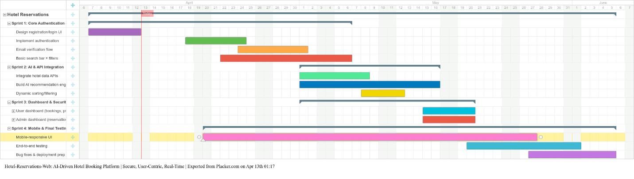

**Figure 1: Project Gantt Chart**